**5.1 Overview**

In this section we’ll looking at the test results of the modules that were built during the whole development process. We’ll be analyzing various graphs and figures of the Zero crossing detector and TRIAC circuits along with the current sensor. We’ll also be talking about the failures that occurred during the conducted experiments and implementations.

**5.2 Zero Crossing Detector**

The output from the Zero crossing detector as seen through an oscilloscope given below:

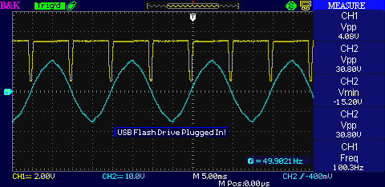

**Figure 5.2a:** Zero Crossing Detector output.

A close up of the zero crossing points is given below:

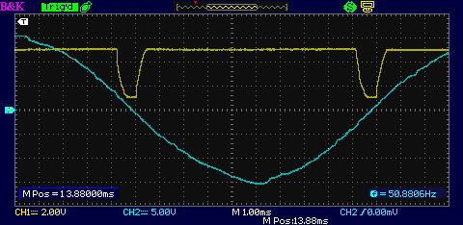

**Figure 5.2b:** Close up look of Zero Crossing Detector.

As seen through the oscilloscope, it is clear that the zero crossing detection is not perfect. There the rise time and the fall time is much higher that usual and is not perfect as there is a exponential rise and fall associated with it. This can be easily misinterpreted by a microcontroller. And hence, to solve this issue, a Schmitt trigger was used and the signal was further processed to get a much better output. The following diagrams show how the signal was read inside the microcontroller before the Schmitt Trigger was added. The values were directly taken from the arduino’s serial monitor within 500ms time at 115200 baudrate.

**Figure 5.2c:** Zero crossing detector output before adding a Schmitt Trigger as read by Arduino.

The table below shows the calculation steps and standard deviation of the zero crossing detection.

|  |  |  |  |  |  |
| --- | --- | --- | --- | --- | --- |
| i | T(ms) | T(s) | Mean | Ti-T(mean) | (Ti-T(mean))^2 |
| 1 | 650 | 0.00065 | 0.000661 | -1.11111E-05 | 1.23457E-10 |
| 2 | 700 | 0.0007 | 0.000661 | 3.88889E-05 | 1.51235E-09 |
| 3 | 600 | 0.0006 | 0.000661 | -6.11111E-05 | 3.73457E-09 |
| 4 | 650 | 0.00065 | 0.000661 | -1.11111E-05 | 1.23457E-10 |
| 5 | 700 | 0.0007 | 0.000661 | 3.88889E-05 | 1.51235E-09 |
| 6 | 700 | 0.0007 | 0.000661 | 3.88889E-05 | 1.51235E-09 |
| 7 | 650 | 0.00065 | 0.000661 | -1.11111E-05 | 1.23457E-10 |
| 8 | 600 | 0.0006 | 0.000661 | -6.11111E-05 | 3.73457E-09 |
| 9 | 700 | 0.0007 | 0.000661 | 3.88889E-05 | 1.51235E-09 |
| SUM | 5950 | 0.00595 |  | 6.50521E-19 | 1.38889E-08 |
|  |  |  |  |  |  |
|  | Mean = |  | 0.000661 |  |  |
|  | Variance= |  | 1.74E-09 |  |  |
|  | Standard Deviation= | | 4.17E-05 |  |  |

**Table:** Sample values with steps to find the standard deviation

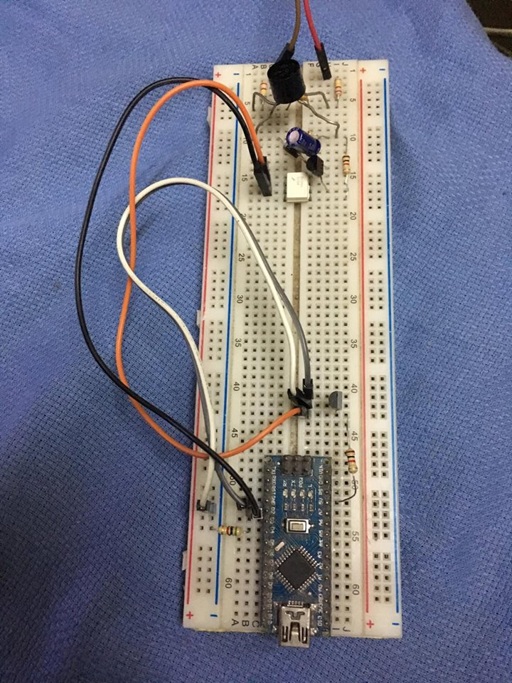

**Figure 5.2d:** Zero Crossing detector implemented on a breadboard for the first time.

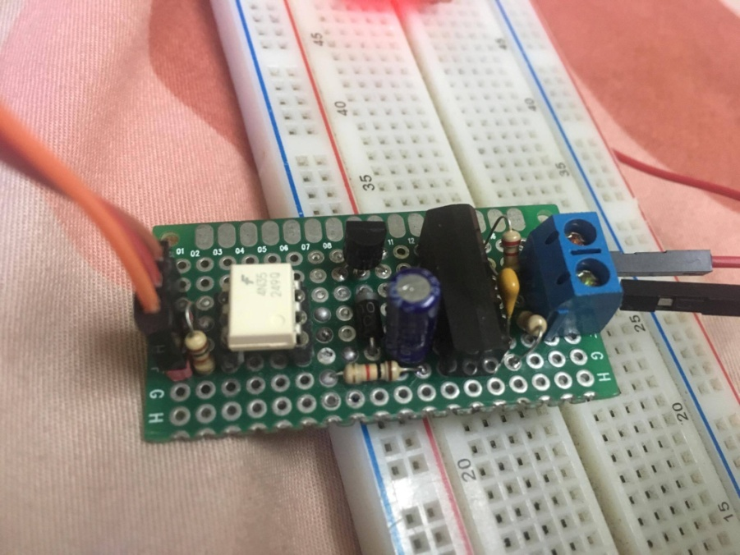

**Figure 5.2e:** Prototype of the first Zero Crossing detector.

**5.3 TRIAC circuit**

The fact that the TRIAC can be used to control current switching on both halves of an alternating waveform allows much better power utilization. However the TRIAC is not always as convenient for some high power applications where its switching is more difficult. TRIACs tend to misfire due to highly capacitive loads and stay ON all the time since the voltage sometimes don’t fall below the turn off thresholds. And because of this, the zero crossing detectors are also affected and does not produce a spike at supposedly zero crossing points.

TRIACs are also incapable of getting damaged due to highly inductive loads as well. Since they are turned on and off very fast at a 100hz frequency, at 50% conduction cycle, inductive loads can create large voltage spikes in the TRIAC which may damage it. This was solved by adding a snubber circuit parallel to the switch. Snubbers are just typical low pass filters that opposes any inductive spikes. They are connected in parallel to the TRIAC and are simply made up of a resistor and a capacitor. But the problem with this circuit is, the resistors need to be able to handle greater than or equal to 1W of power dissipation, which makes it big and the capacitors need to be rated at least 230V, and hence making it bigger as well. Mylar Capacitors are used for this kind of applications. But this external RC snubber was avoided by using the Snubberless TRIACs that has this feature built inside the IC. For this case the BTB04-600B was used that was capable of driving upto 4 ampre consuming load according to the datasheet.

**5.4 Current Sensor**

The current sensor was tested in comparison with the traditional ammeters at different conduction cycles of an AC wave form at a 10% increment. Traditional ammeters are good at measuring pure sinusoidal waves as they average out the signal to finally give us a reading. But our system uses a microcontroller to sample each points of the AC wave and finds the Root-Mean-Squared value of the signal. And hence is it more accurate than traditional ammeters. The graph below show the currents reading from our system and the current read from a traditional ammeter. It can be seen that the RMS system is more linear at distorted sinusoidal waves than the traditional ammeters.

**Figure 5.4:** Comparison between traditional Ammeter and our system.

**5.5 Simulation**

The proteus simulation was done to check and compare the output of the raw ZCD values and the processed Schmitt trigger output. As the results show, the raw ZCD value, even in simulation is showing a distorted pulse, where as the Schmitt Trigger output is more uniform and has a constant rise time and fall time all throughout the cycles. This is desirable as the microcontroller is set to identify the zero crossing pulses through edge triggering interrupt will be able to read the signal without any issue. The Schmitt trigger will also somewhat be able to eliminate any false zero crossing detection which is caused due to noise associated with the mains AC signal.

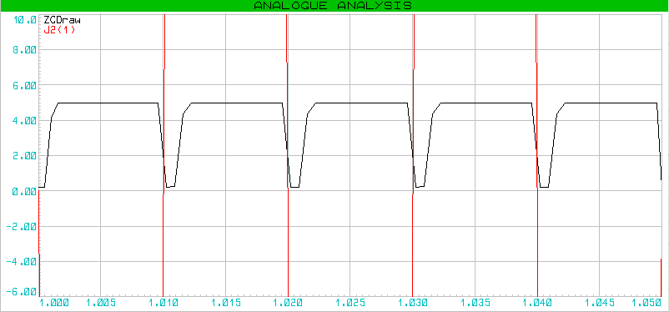

**Figure 5.5a:** The Zero Crossing Detector output without a Schmitt Trigger.

The figure above shows the output of the zero crossing detector without a Schmitt trigger stage. The figure below shows the output when a Schmitt trigger stage is applied. The red lines show the 230V(rms) AC wave zoomed in and the black curve is the raw zero crossing detector value. The blue curve is the Zero crossing detection after a Schmitt trigger was applied.

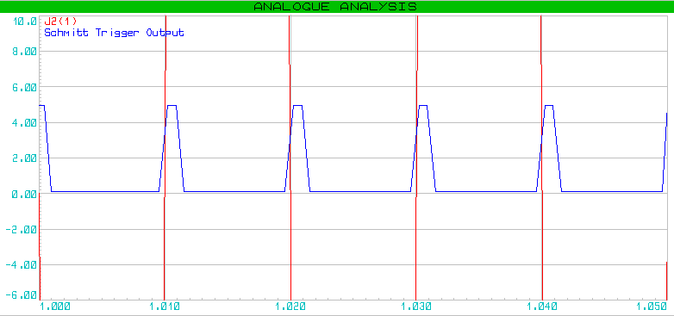

**Figure 5.5b:** The Zero Crossing Detector output with a Schmitt Trigger.

**5.6 Issues**

When frequency was measured using a microcontroller but utilizing the zero crossing detector, the frequency was off by approximately 2Hz and it deviated a lot. Later it was discovered that the code written to calculate the frequency was not correct. The algorithm was to start a timer whenever a Zero crossing interrupt routine was initiated and calculated the frequency when the next interrupt was initiated. But the problem was, the timer stopped whenever an interrupt was initiated and hence the calculations using those timer counts gave us a wrong frequency. The graph below shows the frequency deviation that was caused by this issue.

**Figure 5.6:** AC Mains Frequency Deviation.

**5.7 Summary**

This chapter discussed about the test results circuits that were built during the whole development process. We analyzed various graphs and figures of the Zero crossing detector and the current sensor. We have also mentioned the failures that occurred during the conducted experiments and implementations.